**Part A:**

Part 1-3:

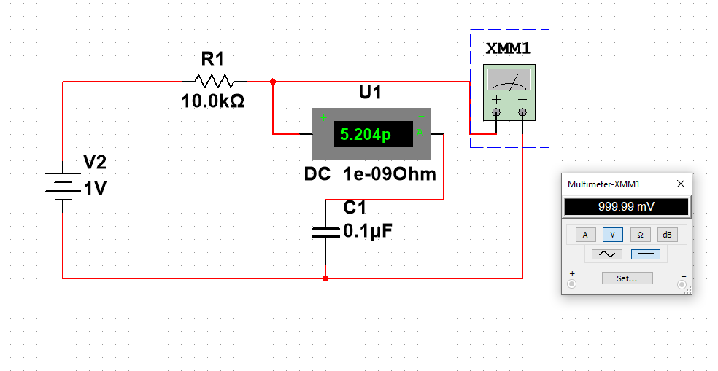

Part 4:

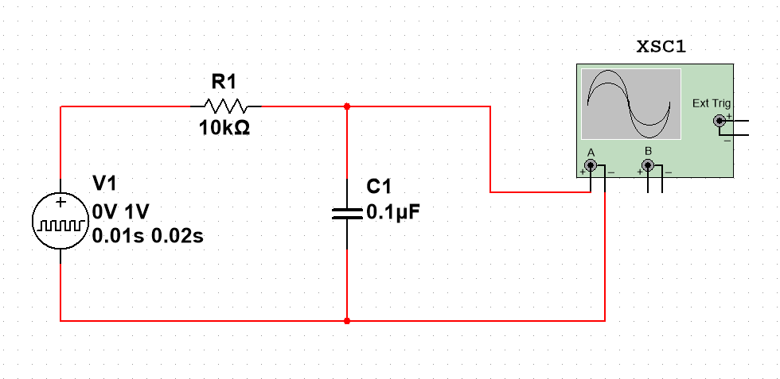

Part 5-6:

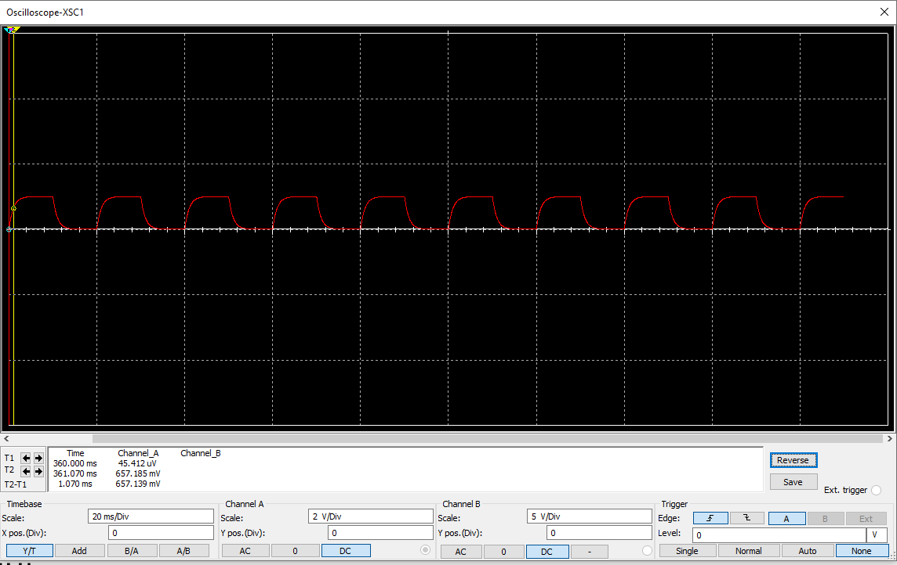

The time it takes to increase to about 63% of the maximum voltage is about 1.07 milliseconds. The theoretical time constant was 1 millisecond

Step 7:

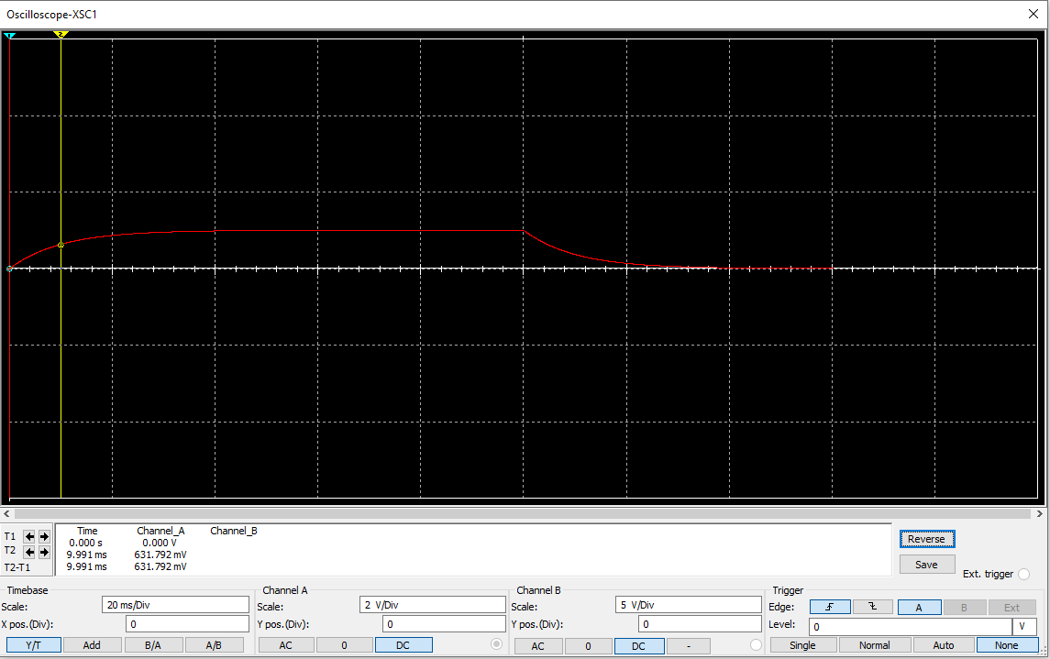

When the resistor is 100k, the time it takes to increase to about 63% of the maximum voltage is about 9.991ms. The difference between the time constant of the10k resistor and the 100k resistor is about by a factor of 10.

Step 8:

At 50 Hz:

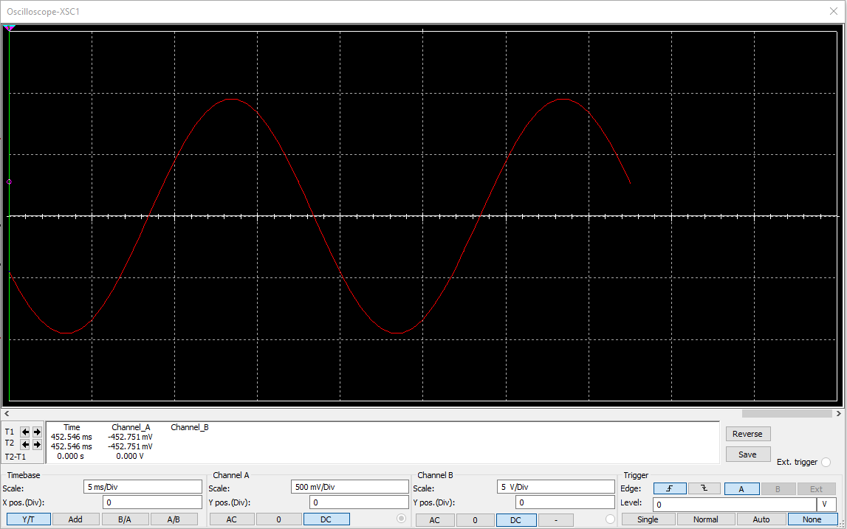

At 1kHz:

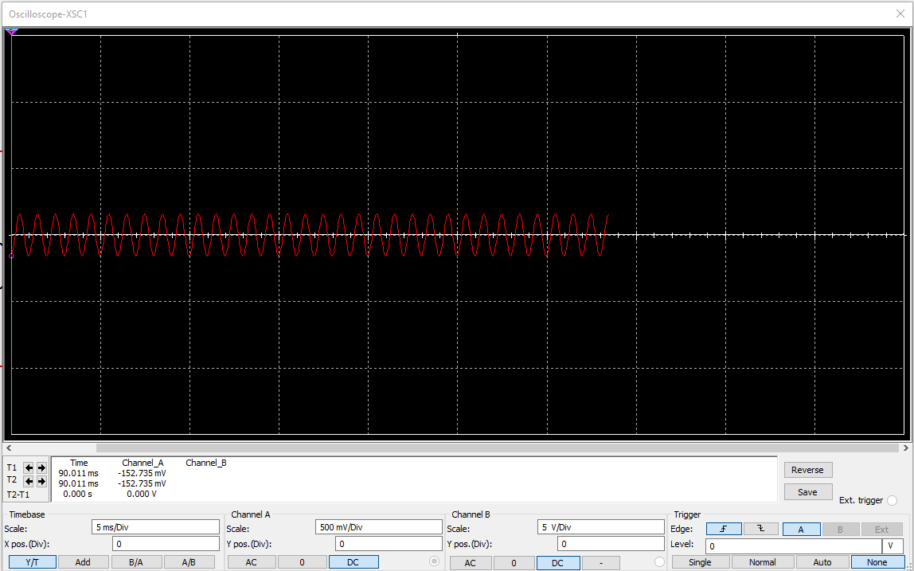

As the frequency increases, the sin wave becomes more and more condensed, as well as having a lower max amplitude.

**Part B:**

Step 1-3:

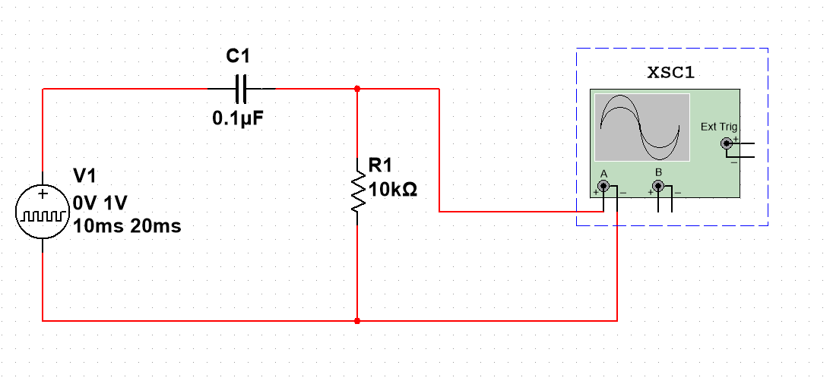

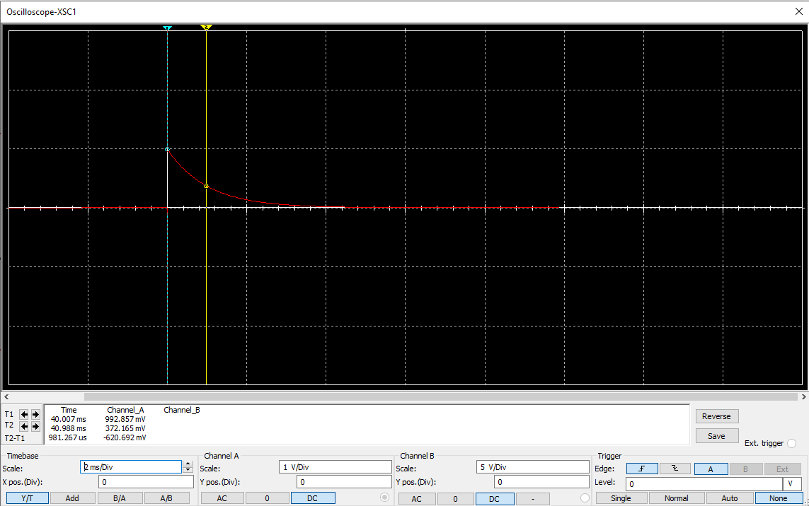

About 981.297 microseconds to reach 37% of maximum voltage

Step 4:

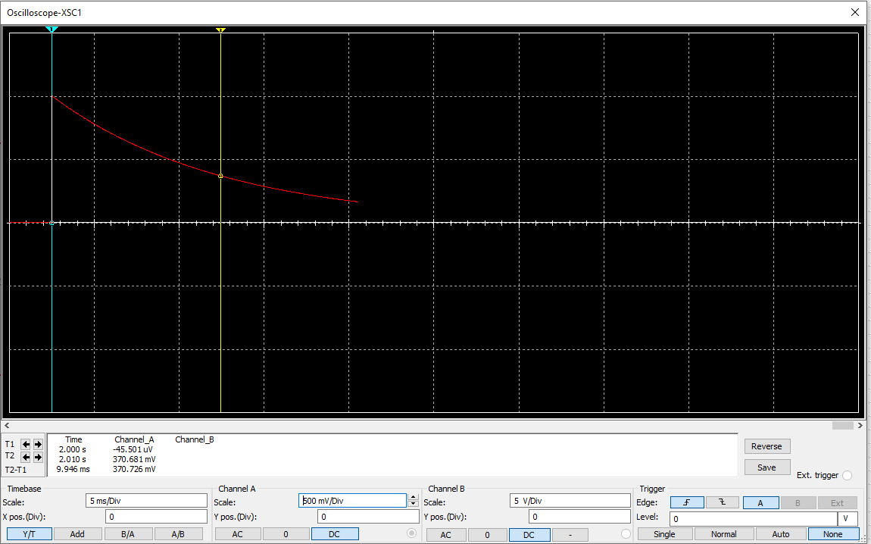

About 9.946 milliseconds to reach 37% of maximum voltage.

The difference between the 10k resistor and the 100k resistor is about a factor of 10.

.

Step 5:

At 50 Hz:

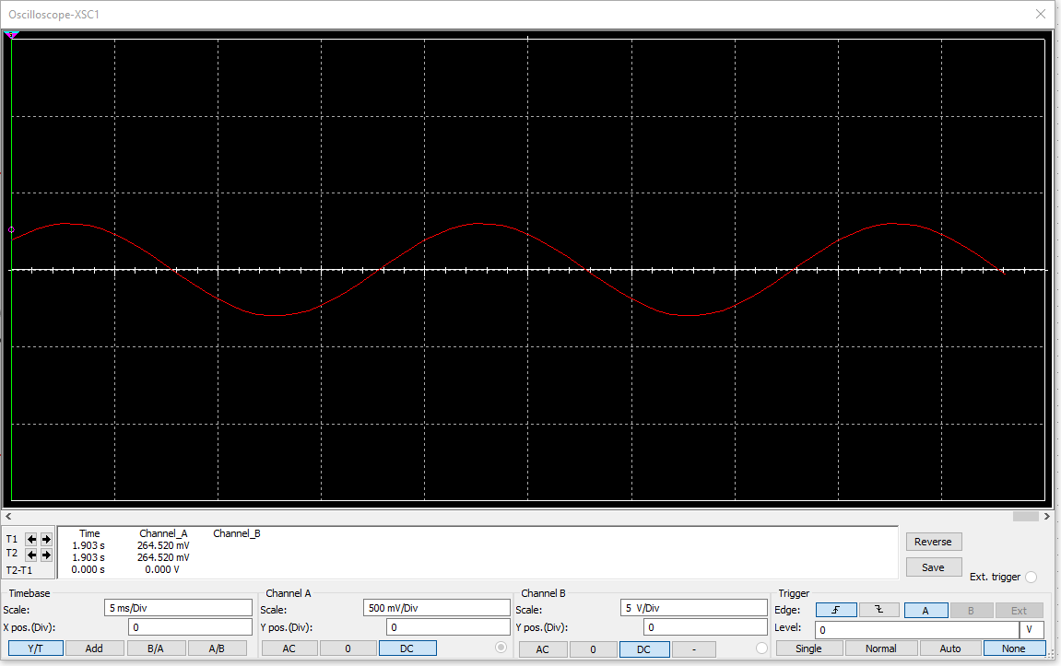

At 1kHz: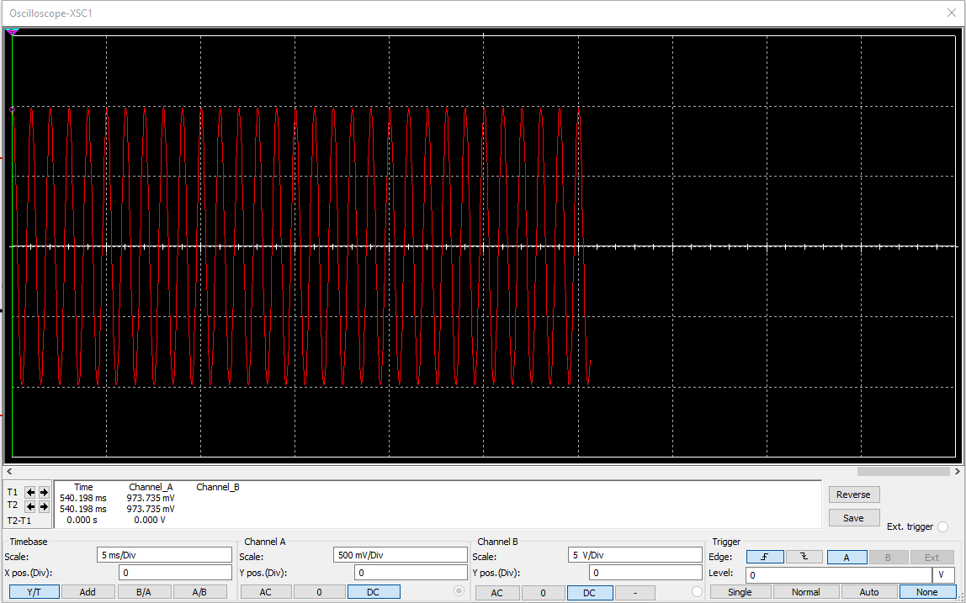

As the frequency increases, the sin waves become more condensed, but the amplitude increases.

**Percentage Error**

Theoretical time constant for 10k = 1 millisecond

Measured for 10k = 1.07 millisecond  
Theoretical time constant for 100k = 10 millisecond

Measured for 100k = 9.991 millisecond

Percentage error for 10k = (1.07 - 1)/1 * 100 = 7%

Percentage error for 100k = (9.991 - 10)/10 * 100 = -0.09%

**High Pass Low Pass**

The first circuit is the low pass circuit while the second circuit is the high pass circuit.